CIDM 6355 Data Mining Methods HW3 Template
(100 points; Due 11:59 PM Central Time, August 2, 2025)
Requirements: This homework is open book, open slides, and open notes, but no collaboration or discussion is permitted before the due time. Any questions about the homework should be directed to the instructor. You must adhere to the instructions, completing all questions and deliverables. This is an individual assignment, so sharing your processes, scripts, screenshots, or answers with others constitutes cheating and will be reported. Additionally, ensure your answers meet the required format to avoid point deductions. Screenshots without date and time will receive a penalty of 50% of points. Identical screenshots will be considered academic dishonesty and will be reported to the university authority. Please acknowledge your understanding and agreement to these requirements by typing your name below.
Type your name: Bolaji Muyiwa

Instruction: Please compile all the deliverables with the required format as below.
- Deliverable 1 (Step 1): Please write down the average for all the five attributes (round them the third decimal place). All these numbers below are the overall centroid for all 325 cities. [5 points]
Attributes | Cost_living | Jobs | Climate | Health_Care | Recreation
Average | 51.910 | 51.023 | 52.040 | 47.870 | 50.230

- Deliverable 2 (Step 4.5): Take a screenshot of your Exampleset (Screenshot 1) [5 points]

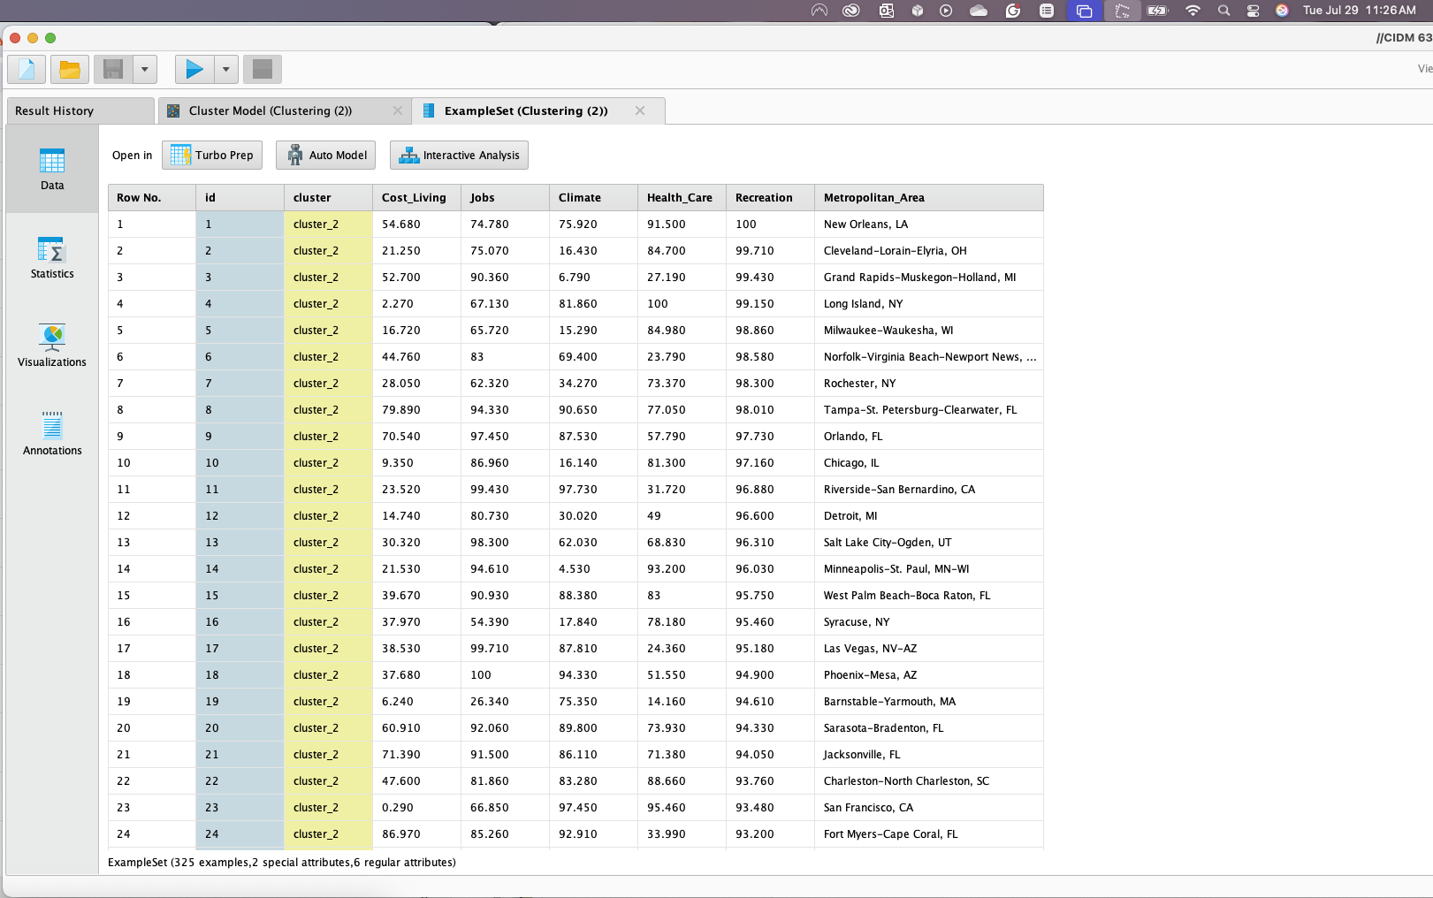
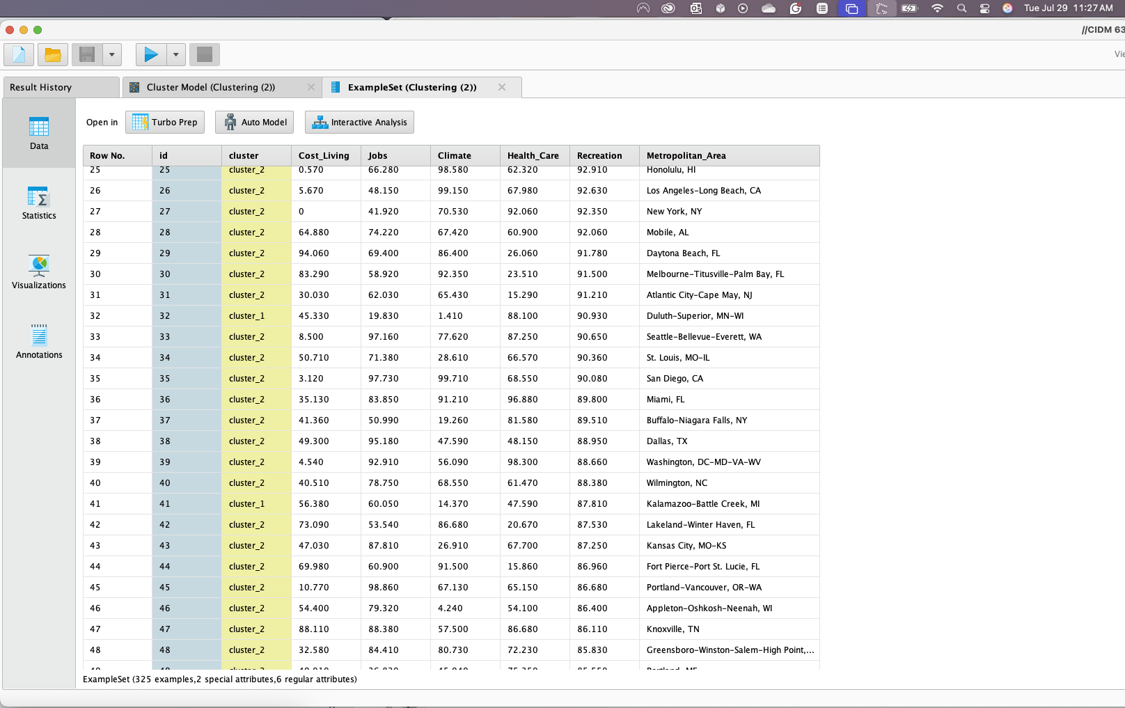
- Deliverable 3 (Step 4.8): based on the results in 4.5-4.8, please discuss the characteristics in each cluster and find an appropriate name for each cluster. For example, Cluster 0 includes 128 cities such as New Orleans, LA and Long Island, NY have highest scores in job opportunities, climate, healthcare, and recreation. However, this group of cities have quite high living cost. We can name this group of cities Metropolitan Luxury…….. [21 points: 7 points for each cluster, including this cluster’s sample size (1 pt.), sample cities (1 pt.), comparison on each dimension (3 pts), and name for this cluster (1 pt.)]

Cluster 0 include 97 cities such as Clarksville-Hopkinsville, TN-KY, cities in Texas such as Laredo, Victoria, Jackson and Ocala FL that have the highest average score for cost living with 74.218 of all the 97 cities and with the highest average score for Climate at 64.929 of all the 97 cities.
With the lowest average score for Health Care and Recreation at 36.013 and 24.197 respectively of all the 97 cities, I think we can name this group of cities a Metropolitan.

Cluster 1 include 101 cities such as Sioux Falla, SD, Casper, WY and Waterloo-Cedar Falls, IA etc. that also have a medium average score at 46.155, 39.153 and 43.089 respectively for Cost of Living, Recreation and HealthCare of all the 101 cities. While Cluster 1 also have the lowest average score for Jobs and Climate with 28.624 and 23.656 respectively for all the 101 cities. I think we can name this group of cities an Average city.

Cluster 2 includes 127 Cities such Daytona Beach, FL, San Antonio, TX, Knoxville, TN etc. that have the lowest average score for the cost of living with 39.448 but have the highest average score for Job opportunity with 76.937 and highest average score for the Health Care and Recreation with the score of 63.846 and 75.784 respectively. I think we can name this group of cities a Metropolitan Luxury.

- Deliverable 4 (Step 6.2): Take a screenshot of your Result History page (Screenshot 2) [5 points]

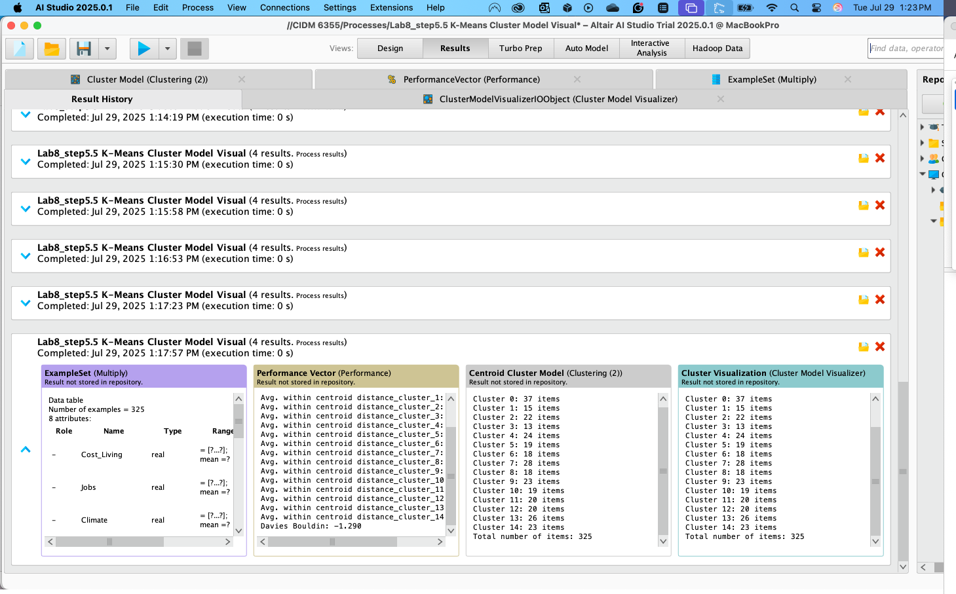

- Deliverable 5 (Step 6.2): Please answer all the question in this deliverable [9 points]
- Based on the table above, when k increases, what happen to Avg. within centroid distance (increasing or decreasing)? [2 points]
- What about Davies Bouldin Index when k increases? [2 points]
- Imagine an extreme case, when k=325, what would Avg. within centroid distance be? [2 points]
- What potential problem will we encounter if we only use Avg. within centroid distance as the main criterion for evaluating clustering models? [3 points]

- As K increases, the average within centroid distance decrease.
- The Davies Bouldin also decreases ad the K increase.
Referencing the K2-K15, For K=2, the Avg. within centroid distance: -2878.835 Davies Bouldin: -1.467 and when K=3,
Avg. within centroid distance: 2460.728 Davies Bouldin: 1.570. the same apply when from K2-15.

- When K=325, the average within centroid distance and Davies Bouldin is 0.000

- It evaluates how close data points are to their own cluster center but says nothing about how far apart clusters are from each other.

More clusters generally reduce within-centroid distance.

- Deliverable 6 (Step 7.1): Draw an elbow chart using either average within centroid distance or DBI for k=2-15. Take a screenshot of your elbow chart with date and time (Screenshot 3). Observe your elbow chart and discuss which k is the best and why. [10 points: 5 points for screenshot and 5 points for your discussion]
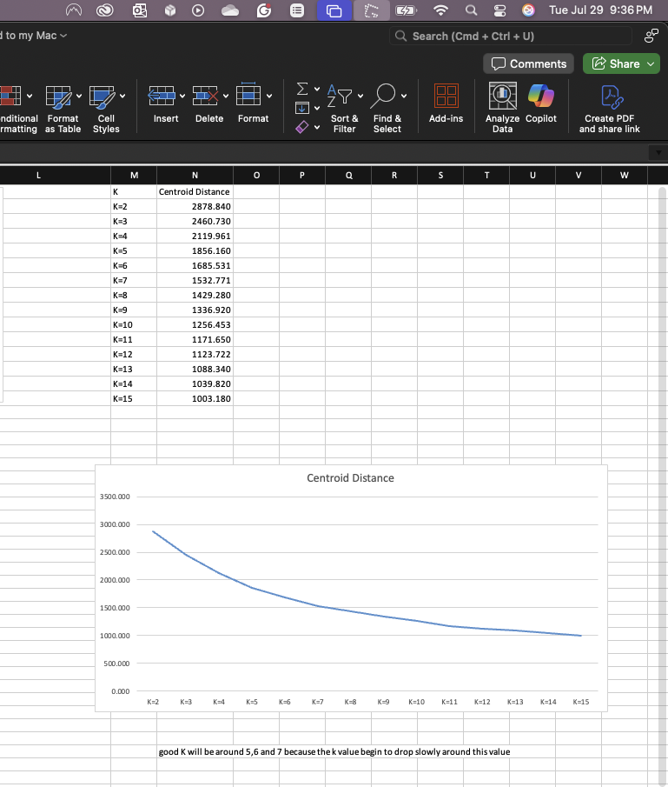

good K will be around 5,6 and 7 because the k value begins to drop slowly around this value

- Deliverable R1: take a screenshot of the result after running the script in Line 19 with date and time (Screenshot 4) and time and briefly interpret the result, explaining what each portion of results means. Your interpretation should cover the following five portions:
- K-means clustering
- Cluster means
- Clustering vector
- Within Cluster Sum of squares
- Available components
Do some research if you do not know what each portion means. [15 points: 5 points for screenshot and 10 points for your interpretation with 2 pts for each portion of results]

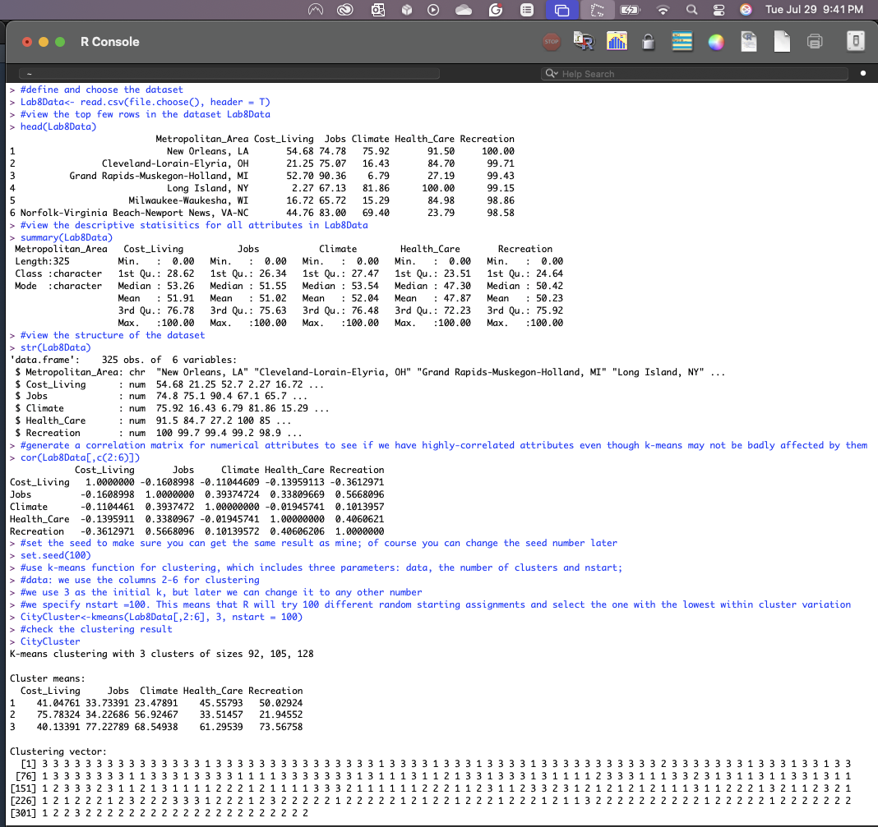

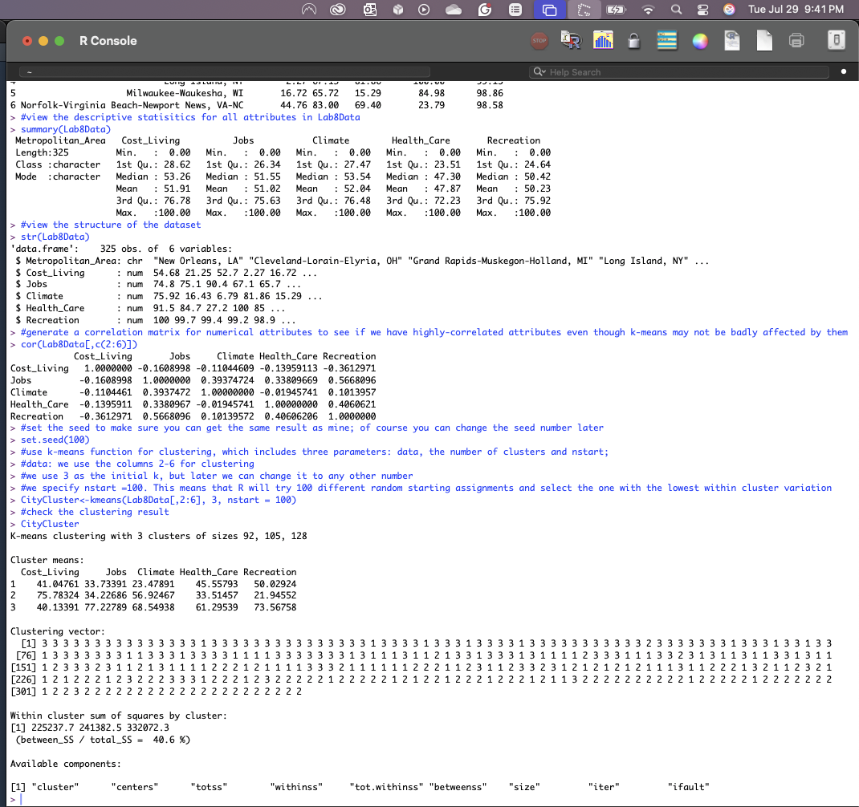

K-means clustering
=======================
The output is from applying K-means clustering to a dataset, where the data is being grouped into 3 distinct clusters.
The numbers represent how many data points were assigned to each:
Cluster 1contains 92 items
Cluster 2 contains 105 items
Cluster 3 contains 128 items
The sizes show how your data is distributed across the clusters.

Cluster means
=============
The output shows the cluster centroids which is the average score values of the attribute in each cluster.

Cluster | Cost of Living | Jobs | Climate | Health Care | Recreation
1 | 41.05 | 33.73 | 23.48 | 45.56 | 50.03
2 | 75.78 | 34.23 | 56.92 | 33.51 | 21.95
3 | 40.13 | 77.23 | 68.55 | 61.30 | 73.57
Cluster 1: This shows moderate average scores, but weak climate scores. we can call the cities here affordable and decent for health and recreation but lacking in job opportunities and climate. It can be grouped into an affordable city

Cluster 2: Here for Cluster 3, it shows high cost of living and moderate climate, but with lower recreation and health care. We can group these cities as urban centers/Metropolitan cities.

Cluster 3: Lastly this shows an ideal low cost of living, good jobs, and high average scores across climate, health, and recreation. These cities can be called the most affordable

Clustering vector
=============
The output shows show the clustering vectors, and each detail correspond to the cluster assigned for a specific data point

This vector is a label for each observation in the dataset, showing whether it fell into Cluster 1, Cluster 2, or Cluster 3.

Referencing the output

Here the first 15 entries are all 3, meaning those first 15 were assigned to Cluster 3, followed by 1 which means the 16th went into Cluster 1. Lastly, we saw some 2s scattered through, those are assigned to Cluster 2.

Within Cluster Sum of squares
======================
From the output of the within clusters sums of squares by clusters,

These values 225237.7, 241382.5, and 332,072.3 shows how —represent how tight the data points are around their cluster centroids. Smaller numbers typically indicate more compact clusters.

For this scenario and output Cluster 1 is the tightest, while Cluster 3 is more dispersed.

Lastly between_SS / Total_SS which is equals to 40.6%, this shows that 40.6% of the total variance in the data is explained by the clustering.

Available components
==================
Explanation and interpretation of the output components are as below

Available Component | Description
cluster | A vector indicating the cluster assignment for example Cluster 1, 2 and 3.
centers | The coordinates of the cluster centroids—average values of each variable per cluster.
totss | Total sum of squares: the overall variance in your dataset before clustering.
withinss | Within-cluster sum of squares for each cluster, showing how compact each cluster is.
tot.withinss | Combined within-cluster sum of squares. Lower means tighter clustering.
betweenss | Between-cluster sum of squares: variance explained by the cluster separation.
size | Number of rows assigned to each cluster.
iter | Number of iterations the algorithm ran before convergence.
ifault | A code indicating success or failure. 0 usually means the algorithm ran without issues.

- Deliverable R2: take a screenshot of the result after running the script in Line 24 with date and time (Screenshot 5) and time and briefly interpret the result, explaining what the result is about and what each column means. [10 points: 5 points for screenshot and 5 points for your interpretation]
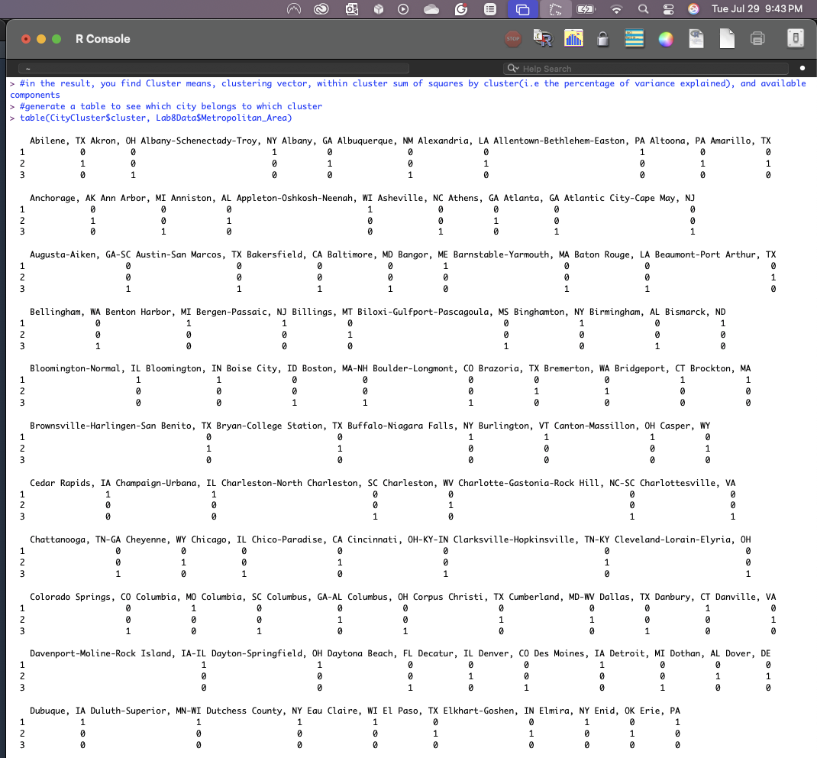

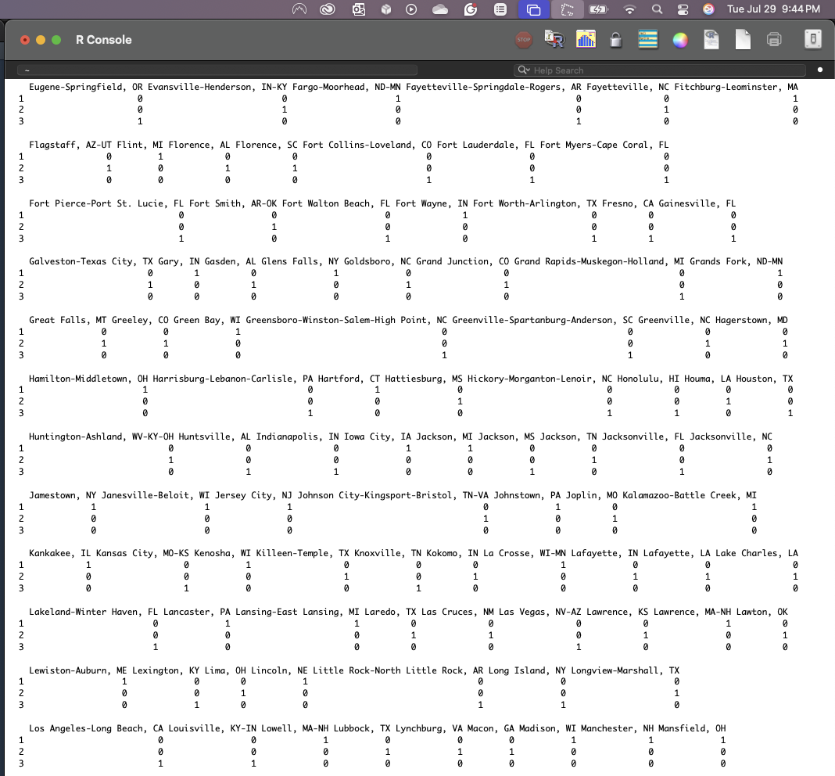
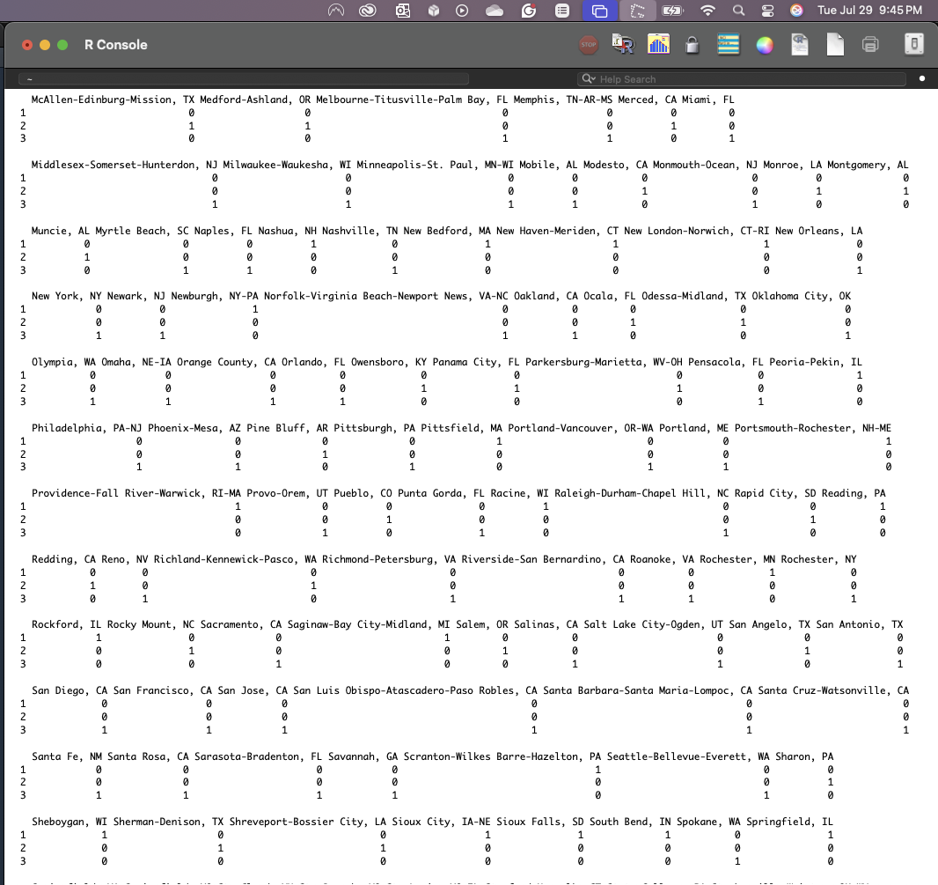

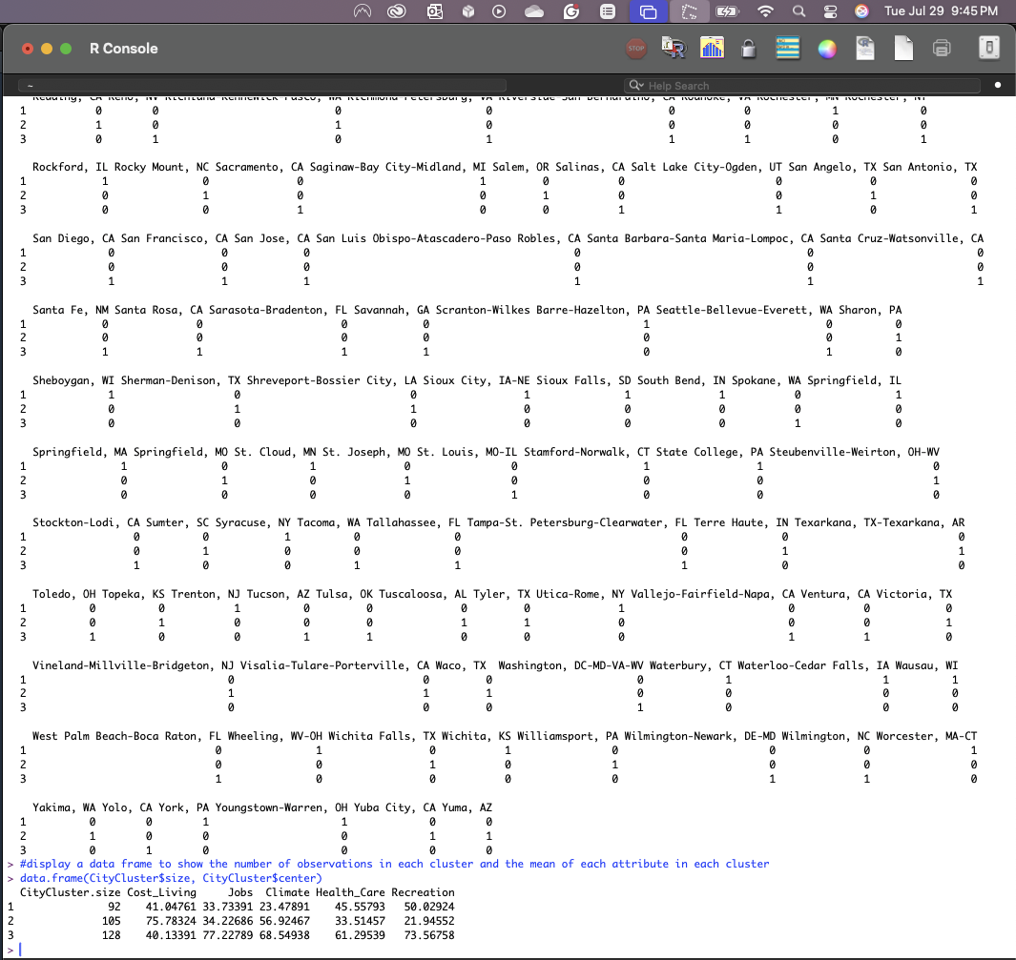

The output shows the results of a k-means where cities are grouped across the 5 Attributes with each individual similarity

CityCluster.size: means how many cities are in each cluster
Cost Living: Average score cost of living for cities in the cluster
Jobs: It’s the average score for job availability.
Climate: The average score for climate in the cities.
Healthcare: It is the average score for health care in the cities.
Recreation: It is the average score for recreation care in the cities.

Further interpretations show that
Cluster 1 with 92 cities has an average lower score for cost of living, moderate recreation, low climate and jobs.

Cluster 2 with 105 cities has the highest average score for cost of living and climate, but lower health care and recreation.

Cluster 3 with 128 cities has the average strong scores in jobs, climate, health care, and recreation which makes it the most livable overall.

- Deliverable R3: take a screenshot of the result after running the script in Line 28 with date (Screenshot 6) and time, and briefly interpret the result, explaining what the result is about and what each column means. [10 points: 5 points for screenshot and 5 points for your interpretation]

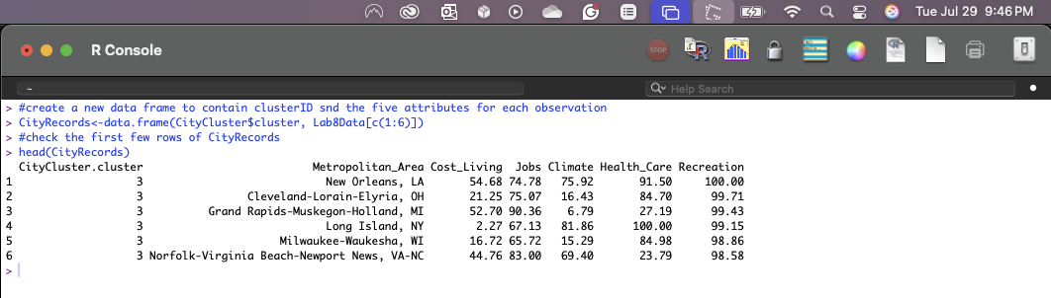

Column Meaning
CityCluster.size: means how many cities are in each cluster
Cost Living: Average score cost of living for cities in the cluster
Jobs: It’s the average score for job availability.
Climate: The average score for climate in the cities.
Healthcare: It is the average score for health care in the cities.
Recreation: It is the average score for recreation care in the cities.

The CityRecords output shows and interpret as below
All the six cities shown in the output here belong to Cluster 3, and they tend to have high scores in Jobs, Climate, and Recreation.

- Deliverable R4: Compare the clustering result for each observation in R (which is saved in CityRecords.csv) and that in RapidMiner (k=3 only). Compare the two clustering results and answer the question: Are the two clustering results in R and RM the same or not? Why? You may follow the instruction in the next slide and take a screenshot of your PivotTable with date and time to support your answer (Screenshot 7). Attention: you cannot just simply compare the cluster name because R and RM may label each cluster differently. For example, New Orleans, LA is labeled as cluster_0 in RM, but Cluster 3 in R, but cluster_0 in RM might be the same with Cluster 3 in R. [10 points: 5 points for screenshot and 5 points for your answer]
The two clustering results in R and RM are not the same.

The reason is that each tools assigned data points to the clusters differently regardless of having the same datasets and clusters

